Kamran Mapar: A17132327

ECE 25

Section 255

Wed 7p - 10p, WLH2211

**ECE 25 Pre Lab 5**

**Fixed lab5shift.v:**

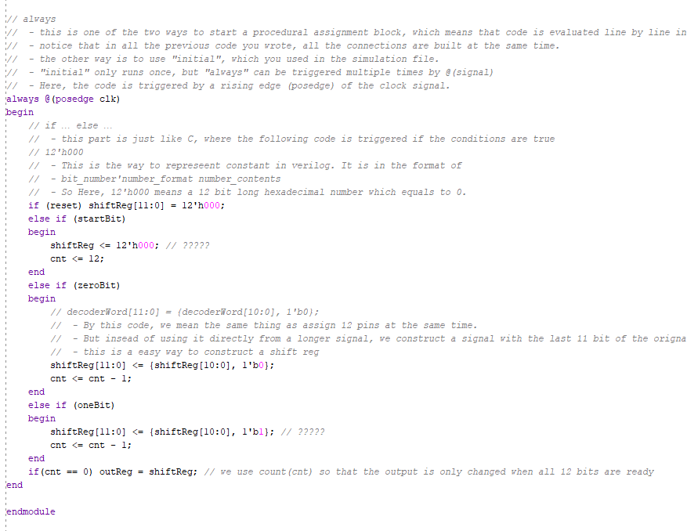

**Top module code:**

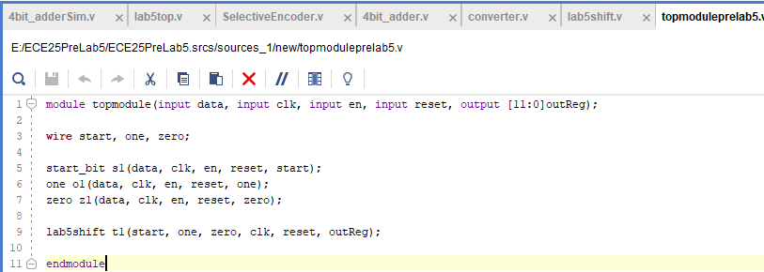

**Simulation code:**

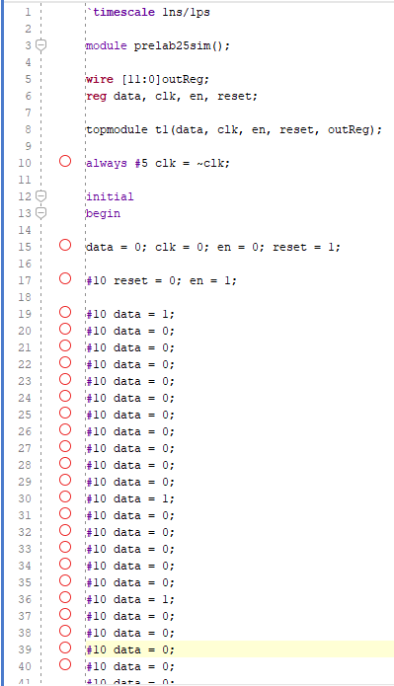

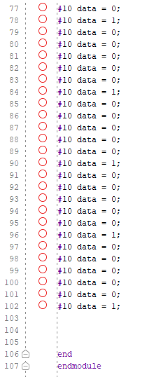

**Simulation output:**

